

SPICES

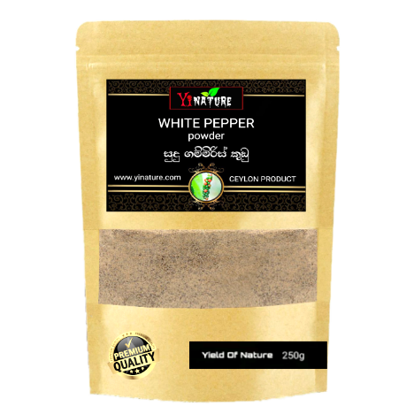
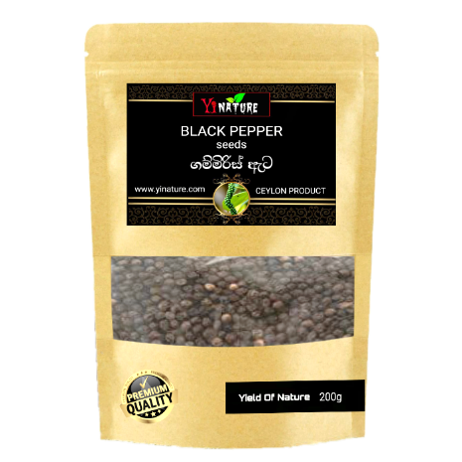
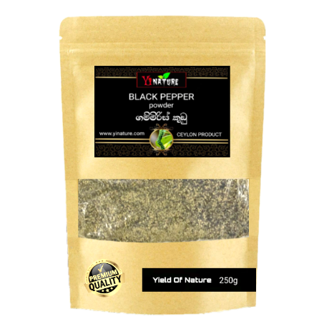
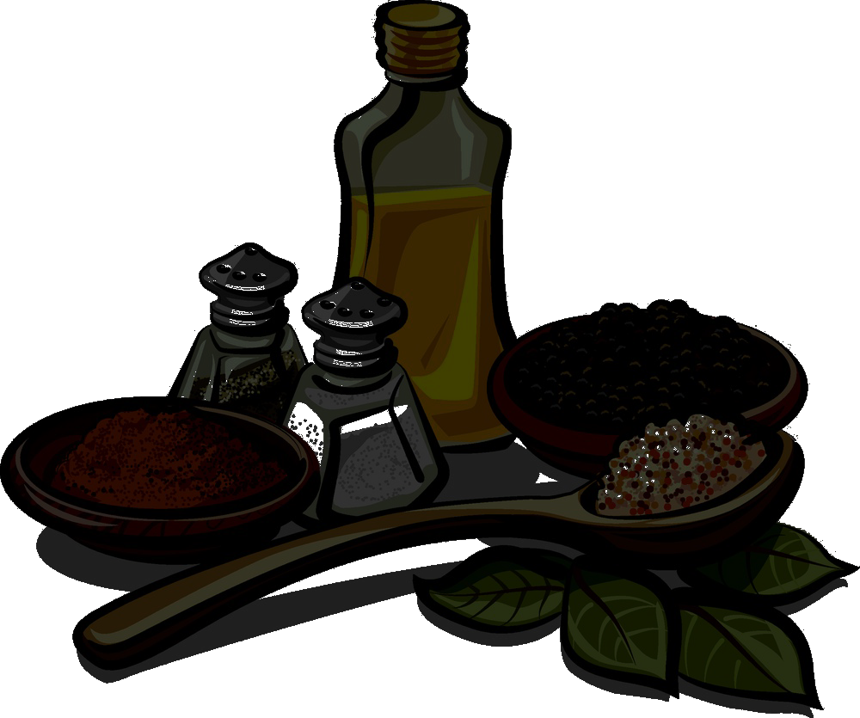
CBLACK PEPPER POWDER

Size : 200g
Who.Price : Rs.390.00
Sale Price : Rs.465.00

Size : 50g | 250g |750g
Who.price(Rs) : 175 | 490 | 1105
S.price(Rs) : 210 | 595 | 1120
::

Size : 50g | 250g
Who.Price (Rs): 205 | 605
Sale Price (Rs) : 245 |725

WHITE PEPPER POWDER
BLACK PEPPER POWDER
CK PEPPER POWDER
BLACK PEPPER CORN pPPPKCDPOWDER
BLACK PEPPER POWDER
CK PEPPER POWDER
BLACK PEPPER POWDER
BLACK PEPPER POWDER
CK PEPPER POWDER



SPICES



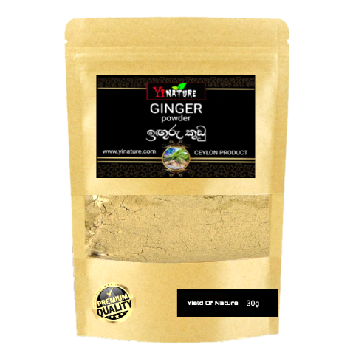
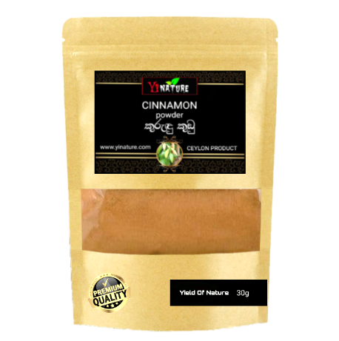
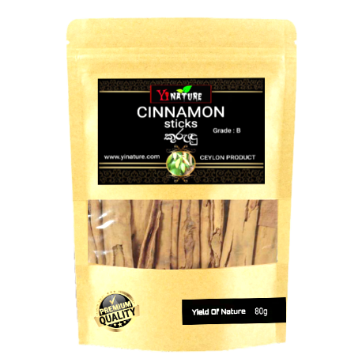
GINGER POWDER
BLACK PEPPER POWDER
CK PEPPER POWDER

Size : 30g
Who.price : Rs:235.00
S.price : Rs: 285.00
::

Size : 30g
Who.price : Rs: 150.00
S.price : Rs: 190.00
::
CINNAMON STICKS
BLACK PEPPER POWDER
CK PEPPER POWDER
CINNAMON POWDER
BLACK PEPPER POWDER
CK PEPPER POWDER

Size : 80g
Who.price : Rs:420.00
S.price : Rs:505.00
::

